Karnataka Valuation & E-Registration (KAVERI - 2.0)
Government of Karnataka

Functional Requirement Specifications

For KAVERI 2.0
Department of Stamps & Registration
Government of Karnataka

Car Parking Registration

Prepared by
Centre for Smart Governance (CSG)
3rd Floor, TTMC Yeshwanthapura, BMTC Bus station
Bangalore – 560022

Contents
1 Introduction 3
2 Document scope 3
2.1 Overview of the function 3
3 Description of the functional requirement 4
3.1 As-Is: Existing process 4
3.2 To-Be: BDA parking registration 5
4 Assumptions 5
5 Validations 6
5.1 Integration with other systems/modules 6
5.1.1 External integration 6
5.1.2 Internal integration with other modules 6
6 Annexures 6
6.1.1 Annexure – 1 – List of modules of Kaveri 2.0 6
7 Annexure – 1 – Clarificatory questionnaire 7
8 Sample XML 8

Introduction
The Department of Stamps and Registration (henceforth referred to as “department”) is the custodian of registered public records such as Registration of Marriages and Firms, Documents of transactions, namely sale, transfer or gift of immovable properties, Mortgage, Power of Attorney, wills and many more. Maintenance and preservation of these critical public records is the prime responsibility of the department. The records or the information associated with registered records are to be made available to the public when requested through defined procedures. The department is also responsible for collecting stamp duty on behalf of the Government for specified transactions. The services are provided through 258 Sub-Registrar Offices (SROs), under the supervision of 35 District Registrar Offices, spread across the state.
The department has computerised the delivery of these services through the development of Kaveri software. KAVERI Online service is a web-based application of the department that provides an interface to the citizens required for documents, marriage, and firm registration. It enables citizens to know the details of stamp duty, property guidelines value, data entry for document registration and marriage registration, etc. The list of modules of Kaveri 2.0 is available in Annexure 1.

Document scope
This document is the Functional Requirement Specification (FRS), outlining the functional features of registering a carparking area within Kaveri 2.0. Currently, Kaveri 2.0 enables citizens to transact properties, including a car park. However, transactions involving only car parking on properties owned by users are not permitted. Implementing this feature facilitates citizens' transactions of only car parking properties by Sale.
Prepared by the Centre for Smart Governance (CSG) and formally approved by the department, this document is intended for the departmental approving authority and the development team.

Overview of the function

Figure 1: BDA parking registration function in Document registration
The registration of the carparking area feature requires minor modifications during the application submission. The stamp duty is calculated based on consideration as there is no market valuation is involved in such transactions. The detailed flow will be discussed further.

Description of the functional requirement

As-Is: Existing process
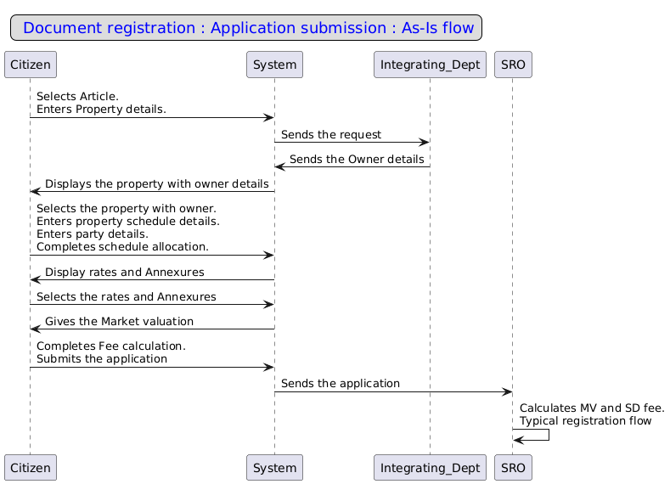
As-Is: Application Submission
- The citizen logs into Kaveri 2.0 and selects the Document Registration module.
- The citizen enters document details, including the nature of the document, article, and sub-article.
- The citizen selects the property type and enters the necessary details.
- The system retrieves the property owner's details from the integrating department.
- The citizen selects the property and inputs relevant data, including property and party details.
- After entering all required information, the citizen calculates the market valuation and stamp duty fee.
- The citizen uploads the executed deed copy along with relevant annexures.
- After uploading all required documents, the citizen selects the SRO and submits the application.
- The system forwards the application to the jurisdictional SRO dashboard for further processing.

To-Be:Car parking registration
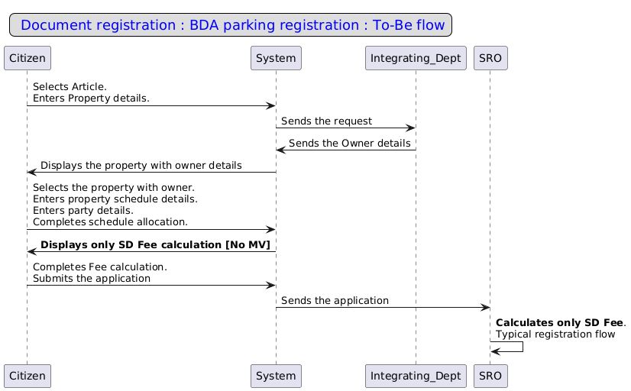

Article Selection | Property Search | Property Schedule | Executant details | Party Allocation | Market Valuation | Fee Calculation | SRO  selection and submission
Addition of a new sub-article
A new article is to be added to the master with the following details
Registration Article | Sale
Stamp Article | Conveyance
Stamp sub-article | Sale of car parking
Parameters of the sub-article
Description | Sale of car parking
Is market valuation required? | No
Stamp Duty and Registration fee calculated on | Consideration Value
SD Calculation | 5% of Consideration
Minimum SD amount | INR 200
Maximum limit | NA
Are exemptions allowed | Yes
Registration Amount | 1% of Consideration
Maximum limit | NA
Minimum limit | INR 200
Is a surcharge applicable? | Yes
Surcharge for Urban | 2% of SD
Surcharge for Rural | 3% of SD
Is cess applicable? | Yes
Cess value | 10% of SD
Is part transaction allowed? | No
Book id | 1
Is an audit required? | TRUE

To-Be: Parking registration: Application Submission
- Article selection: The user selects the sub-article of the sale of car parking.
- Property search: Upon entering the property details, the system retrieves a list of associated properties and owner information. The user selects the property to which the parking transaction is made.
- Market valuation: Market valuation will not be there for these transactions.
- Fee calculation: All the fees will be calculated based on the consideration value, which is keyed in by the citizen. (Provide the example)
- The user continues with the typical registration process.

Assumptions
- Citizens can purchase only a car parking area without owning a flat.
- The system allows the user to add multiple schedules for the transacted parking area.
- After the transaction, XML will be pushed as per the existing process.

Validations
- The system should allow the transactions of the properties with only the car parking area mentioned in the response when the “Sale of car parking” sub-article is selected.
- The system shouldn’t allow the user to proceed further when the properties fetched have the entire property details along with the car parking area when the “Sale of car parking” sub-article is selected.

Integration with other systems/modules

External integration
All the existing integrations will continue

Internal integration with other modules
All the existing integrations will continue

Annexures

Annexure – 1 – List of modules of Kaveri 2.0
Sl No | Module No | Main Module | Sub-Module
1 | 1.1 | Registration | Registration
2 | 1.2 | Registration | Appointment
3 | 1.3 | Registration | Integration module
4 | 1.4 | Registration | Stamp duty and Registration fee calculation
5 | 1.5 | Registration | Guideline value calculation
6 | 1.6 | Registration | Rule 17 (2) filing
7 | 1.7 | Registration | Rule 17 (3) filing
8 | 1.8 | Registration | Old pending release module
9 | 1.9 | Registration | Re-Registration module
10 | 1.1 | Registration | Will after Death
11 | 1.11 | Registration | Filing documents (FRUITS)
12 | 1.12 | Registration | Scanning
13 | 1.13 | Registration | Memo transmission and filing
14 | 1.14 | Registration | 68(2) correction
15 | 1.15 | Registration | Cross-reference Rule 123
16 | 1.16 | Registration | Integration exemption
17 | 1.17 | Registration | Court entry
18 | 1.18 | Registration | Liability
19 | 1.19 | Registration | Status tracking
20 | 1.2 | Registration | Investigation and Search
21 | 1.21 | Registration | Valuation Module (CVC)
22 | 2 | EC
23 | 3 | CC
24 | 4 | Verify Document
25 | 5 | Power of attorney Authentication Module
26 | 6 | Refund Module
27 | 7.1 | Marriage | Hindu Marriage
28 | 7.2 | Marriage | Special Marriage
29 | 7.3 | Marriage | Special Marriage in Other forms
30 | 8 | Legacy record digitisation
31 | 9 | Audit
32 | 10 | Accounts
33 | 11.1 | MIS | Statutory (44)
34 | 11.2 | MIS | Statistical (54)
35 | 11.3 | MIS | Integration (15)
36 | 11.4 | MIS | Computer related (4)
37 | 11.5 | MIS | Reconciliation (5)
38 | 11.6 | MIS | HR (5)
39 | 12.1 | DRO | Firm Registration
40 | 12.2 | DRO | Undervaluation
41 | 12.3 | DRO | Deposit of will
42 | 12.4 | DRO | Adjudication of documents
43 | 13 | IGRO | Appeal
44 | 14 | Master Data Management
45 | 15 | User Management
46 | 16 | Mobile application
47 | 17 | Training Module | Master Trainer, Training Plan

Annexures

Clarificatory questionnaire
- Can the car parking be mortgaged, gifted or partitioned after registration?

Sample XML
{
"responseData": {
"generalInfo": {
"dataSources": "New Khata, Structure",
"khataRequestId": 120573
},
"ownerDetails": [
{
"propertyOwnerClassification": "2",
"noOfJpointApplicants": "",
"propertyOwnership": "2",
"ownershipType": "",
"ownerData": [
{
"ownerGivenName": null,
"nameOfRelation": null,
"relationType": null,
"panNumber": null,
"ownershipAcquiredType": null,
"otherIDForProofType": null,
"otherIDNo": null,
"ownerPermanentAddress": null,
"ownerPermanentPinCode": null,
"ownerCommunicationAddress": null,
"ownerCommunicationPincode": null,
"photo": null,
"mobileNo": null,
"emailID": null,
"jointAlloteeList": [
{
"ownerGivenName": null,
"otherIDForProofType": null,
"otherIDNo": null,
"ownerPermanentAddress": null,
"ownerPermanentPinCode": null,
"ownerCommunicationAddress": null,
"ownerCommunicationPincode": null,
"photo": null,
"mobileNo": null,
"emailID": null,
"relationType": null,
"nameOfRelation": null,
"panNumber": null
}
]
}
]
}
],
"organisations": [
{
"organisationName": "Bangalore Development Authority",
"otherIDForProofType": null,
"otherIDNo": null,
"ownershipAcquiredType": null,
"panNumber": null,
"permanentAddress": null,
"permanentPinCode": null,
"communicationAddress": null,
"communicationPinCode": "560020",
"mobileNo": null,
"emailID": "commissioner-bda@ka.gov.in",
"representativeDetails": [
{
"organisationsAuthorisedRepresentativeName": "Commissioner",
"organisationsAuthorisedRepresentativeRelationName": null,
"organisationsAuthorizedRepresentativeDesignation": null,
"organisationsAuthorizedRepresentativePhoto": null,
"repRelationship": null,
"otherIDForProofType": null,
"otherIDNo": null,
"panNumber": null,
"repPermanentAddress": null,
"repPermanentPinCode": null,
"repCommunicationAddress": null,
"repCommunicationPinCode": null,
"photo": null,
"mobileNo": null,
"emailID": null
}
]
}
],
"propertyDetails": {
"propertyIndentification": {
"bdaPID": "T000062584",
"ulmsOfficeCode": null,
"ulmspin": null,
"propertyOldNumber": null
},
"propertyCharacterstics": {
"depatmentPropertyClassification": "1",
"developmentSubType": "2",
"propertyType": "3",
"propertyClassification": null
},
"khataDetail": {
"khataNo": null,
"khata_Approval_Date": "2025-03-20T13:50:56.853667"
},
"site": {
"siteNo": null,
"surveyNo": null,
"landusepropertyCategory": "",
"cornerSite": "2",
"dimensionUoM": "",
"siteMeasurementN": null,
"siteMeasurementE": null,
"sitelandExtentUoM": "",
"siteLandExtent": null,
"oddSite": "",
"doestheoddsitehavea1anda2categories": "",
"dimensions_of_odd_site_eastwest": null,
"dimensions_of_odd_site_northsouth": null,
"a1": null,
"a2": null,
"totalofa1anda2": null,
"coordinateType": null,
"latitude": 0,
"longitude": 0,
"checkbandiDetail": {
"landCheckbandiE": null,
"landCheckbandiW": null,
"landCheckbandiN": null,
"landCheckbandiS": null
},
"landParcels": [
{
"parcelType": null,
"dimensionUom": null,
"lengthOfSide1": null,
"breadthOfSide1": null,
"lengthOfSide2": null,
"breadthOfSide2": null,
"siteExtentUom": null,
"landParcelSiteExtent": null
}
]
},
"buildingApartment": {
"basePID": "T000062584",
"doorNo": null,
"buildingExtentUOM": "",
"plinthArea": null,
"builtUpArea": null,
"carpetArea": null,
"buildingSaleableExtent": null,
"restrictedOrAdditionalBuiltUpArea": null,
"udrOrLandShareFraction": null,
"udrUoM": "",
"udrAreaOrLandShareArea": null,
"buildingBlockuseOrPremiseUse": null,
"buildingBlockSubUse": null,
"totalNoOfFloors": "",
"parkingdetails": {
"parkingAvailable": null,
"totalParkingUnits": null,
"parking_Extent_UoM": "1",
"totalParkingArea": "13.75",
"twoWheelerparkingUnits": null,
"fourWheelerparkingUnits": null,
"coveredCarParkingAreaUOM": null,
"coveredCarParkingArea": null,
"openCarParkingAreaUom": null,
"openCarParkingArea": null,
"twoWheelerParkingAreaUom": null,
"twoWheelerParkingArea": null,
"parkingSpecific": [
{
"base_bda_pid": "T000062584",
"parking_lot_no": "141",
"parking_type": 2,
"floor_no": "BASEMENT",
"parking_extent_uom": 1,
"total_parking_extent": "13.75",
"parking_dimension_uom": 1,
"parking_east_west": "3.66",
"parking_north_south": "6.94",
"parkingCheckbandiDetails": {
"parkingCheckbandiE": "C P 140",
"parkingCheckbandiW": "C P 142",
"parkingCheckbandiN": "DRIVEWAY",
"parkingCheckbandiS": "WALL"
}
}
]
},
"apartmentadditionalinfo": {
"nameOfTheProjectComplex": null,
"phaseNo": null,
"floorNo": null,
"premiseNoOrFlatNo": null,
"flatExtentUOM": "",
"flatBuiltupArea": null,
"flatCarpetArea": null,
"flatSaleableExtent": null,
"additionalBuiltupArea": null,
"bhk": "",
"apartmentBlockNo": null,
"buildingBlockName": null,
"ownersAssociationName": "",
"ownersAsscociationCode": "",
"checkbandidetail": {
"flatCheckbandiE": null,
"flatCheckbandiW": null,
"flatCheckbandiN": null,
"flatCheckbandiS": null
}
},
"floordetails": [
{
"floorNo": null,
"floor_Area_UoM": null,
"floor_BuiltupArea": null,
"floor_CarpetArea": null,
"floor_additionalBuiltupArea": null,
"year_of_Construction": null,
"occupancyStatus": null
}
]
},
"utilities": {
"escomCustID": null,
"waterID": null,
"gasConnectionAccountNo": null,
"ugdConnectionNo": null
},
"otherDetails": {
"appl_ref_no": "ULBD01019002108",
"isLeasePeriodInForce": "2",
"isLoanAvailedOnProperty": "",
"masterPlanRef": null,
"possessionCertificateNo": null,
"possessionCertificateIssuedDate": null,
"planapprovalordernunber": null,
"planapprovalorderdate": null,
"releaseorderno": null,
"releaseorderdate": null,
"allotmentLetterReferenceNo": null,
"allotmentLetterReferenceDate": null,
"landapprovalnumber": null,
"landapprovalDate": null,
"buildingLicenseNumber": null,
"buildingLicenseDate": null,
"occupancyCertificateNumber": null,
"occupancyCertificateDate": null,
"deedreferenceNumber": null,
"deedreferenceDate": null
},
"propertyTax": {
"assessmentNo": null,
"taxpaymentdate": null,
"challanNo": null,
"totalAmount": null,
"taxAssessmentYear": null,
"paidStatus": null
},
"additioninfo": {
"remarks": ""
}
},
"rights": [
{
"rightsType": null,
"rightsDescription": null,
"enteredby": null,
"enterdate": null
}
],
"liabilities": [
{
"liabilitiesType": null,
"liabilitiesDescription": null,
"enteredby": null,
"enterdate": null
}
],
"propertyRecordDetails": {
"pRApplicationNo": null,
"pRApplicationDate": null,
"appliedAt": null,
"scCode": null,
"approvedDate": null,
"paymentDetails": {
"receiptNo": null,
"prFee": null,
"prPaymentDate": null,
"modePaymentBank": null,
"transactionRefNo": null
}
},
"landLocation": {
"locationClassification": null,
"stateDivision": null,
"localDivision": null,
"cityTown": null,
"districtName": null,
"districtLGDCode": null,
"talukName": "",
"hobliName": null,
"layoutName": null,
"subLayoutName": null,
"villageName": null,
"stage": null,
"phase": null,
"block": null,
"sector": null,
"circle": null,
"department": "Urban Development (ACS)",
"departmentcode": "03",
"developmentauthority": "BDA",
"localBody": null,
"officecode": "0302010001",
"officename": "BDA",
"revWardNo": null,
"revWardName": null,
"revWardBlockNo": null,
"revWardBlockName": null,
"roadStreetID": null,
"roadStreetName": null
},
"sdCalculation": {
"sdExtentUoM": "1",
"sdsiteLandExtent": null,
"sdBuildingSaleableExtent": null,
"sdFlatSaleableExtent": null,
"sdParkingSaleableExtent": "13.75",
"sdTdrSaleableExtent": null
},
"document": {
"landapproval": null,
"buildingLicense": null,
"occupancyCertificate": null,
"idProof": null,
"addressProof": null,
"saleDeed": null,
"motherDeedOrPreviousSaleDeed": null,
"encumbranceCertificate": null,
"taxPaidReceiptCurrentYear": null,
"possessionCertificate": null,
"allotmentLetter": null,
"leaseCumSaleDeed": null,
"correctDimensionCertificate": null
}
},
"responseCode": "200",
"message": "Successful"
}

